**BANK LOAN REPORT QUERY DOCUMENT**

1. **BANK LOAN REPORT | SUMMARY**

**KPIs:**

**Total Loan Applications**





**MTD Loan Applications**





**Previous MTD (PMTD) Loan Applications**





**Total Funded Amount**





**MTD Total Funded Amount**





**PMTD Funded Amount**





**Total Amount Received**





**Total Amount Received Month To Date (MTD)**





**Total Amount Received Month To Date (PMTD)**





**Average Interest Rate**





**MTD Average Interest Rate**





**PMTD Average Interest Rate**





**Average Debt To Income Ratio (DTI)**





**MTD Average DTI**





**PMTD Average DTI**





**GOOD LOAN ISSUED**

**Good Loan Percentage**

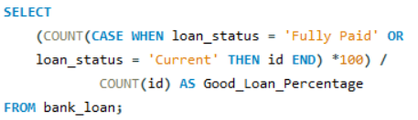



**Good Loan Applications**

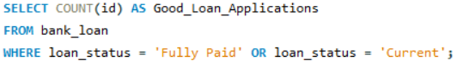



**Good Loan Funded Amount**

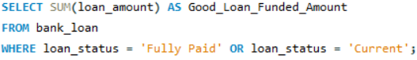



**Good Loan Amount Received**

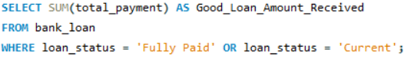



**BAD LOAN ISSUED**

**Bad Loan Percentage**

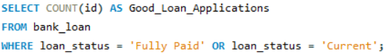



**Bad Loan Applications**

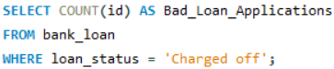



**Bad Loan Funded Amount**

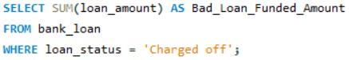



**Bad Loan Amount Received**

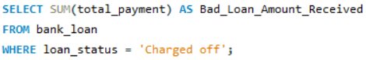



**LOAN STATUS**

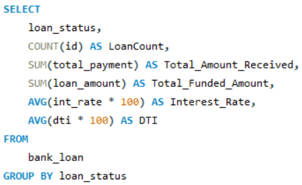

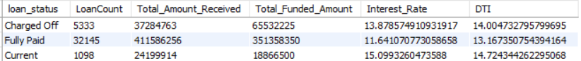

**MTD Loan Status**

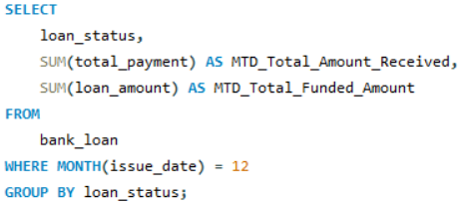

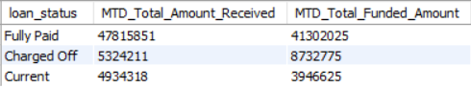

1. **BANK LOAN REPORT | OVERVIEW**

**MONTH**

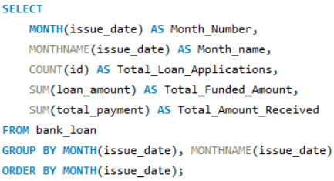

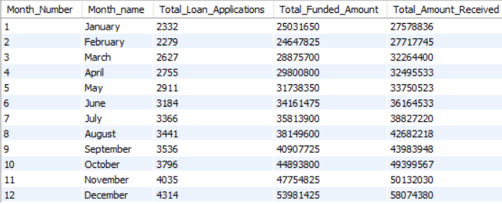

**STATE**

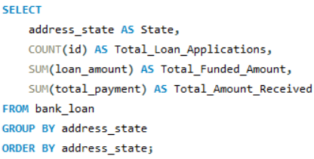

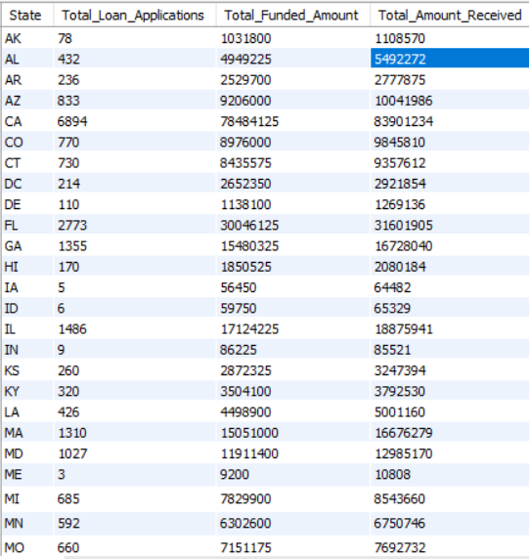

**TERM**

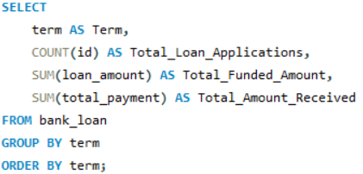

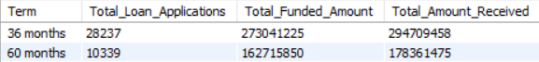

**EMPLOYEE LENGTH**

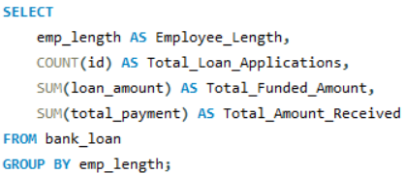

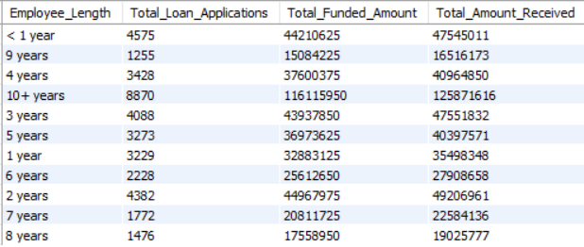

**PURPOSE**

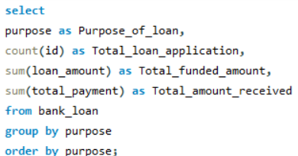

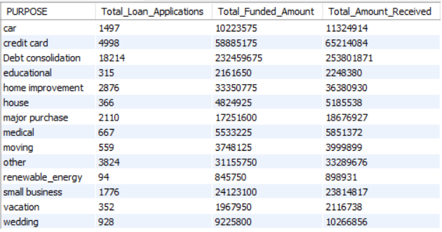

**HOME OWNERSHIP**

